**NATIONAL UNIVERSITY OF COMPUTER AND EMERGING SCIENCES**

CL307 COMPUTER NETWORKS LAB

**Lab#03 Activity**

1. **Configuring bus Topology Network in Cisco Packet Tracer. (With intermediate device Hub).**

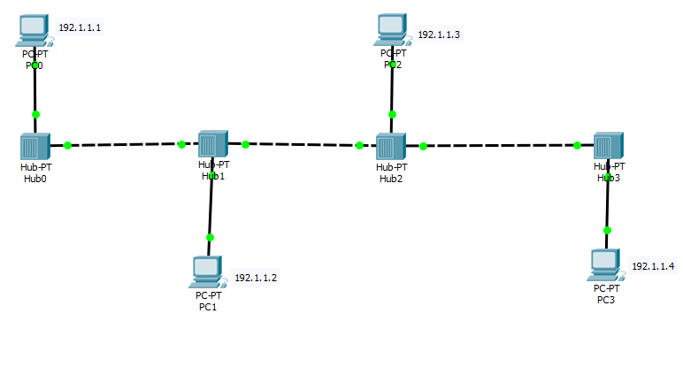

1. Assign mentioned IP addresses to each end devices.
2. Switch simulation mode.
3. Send PDU from PC0 to PC2 and PC1 to PC0.

Q1. Write what you analyze, how star topology works?

______________________________________________________________________________ ______________________________________________________________________________

1. **Configuring star Topology Network in Cisco Packet Tracer. (With intermediate device Hub).**

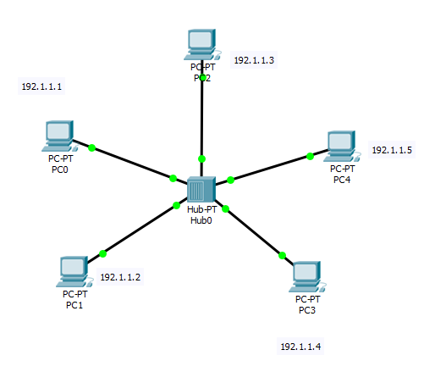

1. Assign mentioned IP addresses to each end devices.
2. Switch simulation mode.
3. Send PDU from PC0 to PC3 and PC4 to PC3.

Q1. Write what you analyze, how star topology works?

____________________________________________________________________________________________________________________________________________________________

Q2. Write down the difference between working mechanism of both topology, and which topology is better and why?

____________________________________________________________________________________________________________________________________________________________

1. **Configuring ring Topology Network in Cisco Packet Tracer. (With intermediate device Hub).**

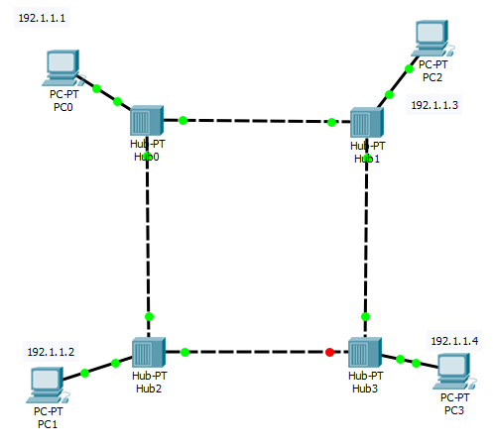

1. Assign mentioned IP addresses to each end devices.
2. Switch simulation mode.
3. Send PDU from PC1 to PC3

Q1. Write what you analyze, how ring topology works?

___________________________________________________________________________________________________________________________________________________________

Q2. Write down the working mechanism of ring topology, and which topology is better and why?

____________________________________________________________________________________________________________________________________________________________

1. **Configuring mesh Topology Network in Cisco Packet Tracer. (With intermediate device Hub).**

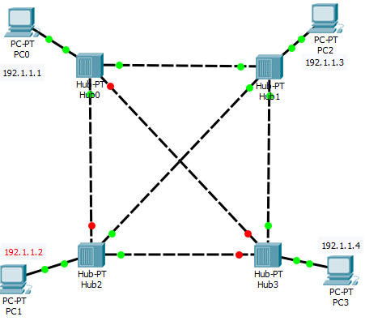

1. Assign mentioned IP addresses to each end devices.
2. Switch simulation mode.
3. Send PDU from PC1 to PC3 and PC2 to PC1

Q1. Write what you analyze, how mesh topology works?

___________________________________________________________________________________________________________________________________________________________

Q2. Write down the working mechanism of mesh topology, and which topology is better and why?

____________________________________________________________________________________________________________________________________________________________

**Home Task.**

We configure Bus, Ring, Star, Mesh topology with (Intermediary device) hub, and analyzed the working mechanisms of all, now your home task is to configure all topology in same manner with (Intermediarydevice) switch.

* In the end of activity write a short answer: What you analyze, explain difference between working mechanism of hub and switch.